Opsins: A perspective on vision

In the field of biology there have always been a certain fascination with the visual system, at every technological advancement the research into the eyes have been deepened (Koenig and Gross 2020). The current understanding of the visual system are thus the result of several significant advancements in all of the related fields of study, the current situation allows researchers to understand how animals process the visual inputs they are subjected to.

Animal eyes vary greatly in their complexity and morphology, universally all eyes consists of several components. These components have been co-opted from their former functions, one of the components that have been co-opted is paralogue to the modern opsins (Picciani et al 2016.).

# Theory

## Opsins form and function

Opsins in form and function are similar to other GCPR’s (G-coupled protein receptors), they can however be distinguished from these as they have lysine residue in the seventh transmembrane helix (Terakita 2005). The opsin is associated with retinal, when these two are associated they form the photosensitive unit rhodopsin (Terakita 2005). The function of the lysine is as a coupling point for the cis-retinal to the seventh helix of the opsin (Okada and Palczewski 2001), this coupling allowing for the activation of the g-protein when its ligand (retinal) goes through conformational changes. The rhodopsin changes its shape as a consequence of light absorption, this leads it through some intermediate states until it arrives at it the active meta-II state (F. J Bartl et al 2001). In this active state it can bind to and activate the g-protein, thereby relaying the signal from initial photon absorbed by the opsin to the ganglia.

Rhodopsin as a unit consists of the opsin, an apo-protein and the 11-cis-retinal, the cis retinal is based on vitamin A (Zhang et al 2016). GCPR are normally dimers, however it has been thought that rhodopsin functions as a homodimer along with its apo-protein. Evidence however suggest that the opsins dimerize, Zhang et al 2016 found that dimerization stabilize the opsins in mice.

Opsins functions and stereoisometric form can vary greatly, some are utilized as a key component in vision. There are however also opsins utilized in other functions of the body, these can for instance be light dependent ion pumps. Their function can be split up into two phases as described above, first the photon absorption and secondly the activation of the GCPR (Terakita 2005).

The activation happens through a conformational change in the retinal, this occurs by changing the retinal from its cis conformation to the trans conformation. The change leads to a cascade which end with a physiological response, the entire process is known as phototransduction (Yoshinori Shichida and Take Matsuyama 2009). The retinals conformational change leads to changes in the structure of the associated g-protein, this leading to an activation of its cascade (Okada and Palczewski 2001). There are different cascades activated dependent on the g-protein, the variation in the cascades activated lead to different physiological responses, in this paper the relevant ones are TRP and CNG channel activation. As these are the channels that have been found to be used by *Cnidaria*,

The retinal must then be returned to its cis conformation, in vertebrate (rod) vision the retinal must dissociate from the complex and be re-isomerized in the surrounding epithelium. In invertebrate vision this can be done without the disassociation (Hardie and Raghu 2005), as *Cnidaria* utilize the TRP pathway the re-isomerization happens without this disassociation. Termination of the signalling cascade is an important part of the specificity of the signalling, regulation of the G-protein signalling makes temporal sampling possible (Hardie and Raghu 2005).

The absorption spectrum of each opsin is determined through their amino sequence (Anders kilde her), the amino sequence determines how the amino acids interacts when the opsins is folded. Thereby determining the 3 dimensional shape of the opsins, this controls which wawelengths of light lead to a conformational change and thereby a response. The opsin is therefore responsible for tuning the visual sense to a certain part of the electromagnetic spectrum, each opsin therefore having its own often distinguishable absorption spectrum.

In vision there are 2 primary forms of phototransduction, there is the ciliary phototransduction and rhapdomeric phototransduction. When TRP channels are activated in ciliary phototransduction the result is a depolarization, while the CNG channel activation utilized in rhapdomeric phototransduction result in a hyperpolarization (D. C. Plachetzki et al. 2010). The result is 2 very distinctively different ways to process vision, this difference can be seen between animals like *Cnidaria* and humans. It can be seen via a visualization of the membrane potential, the difference between the hyperpolarization and depolarization can be clearly distinguished.

The g proteins that the opsins utilize can be used to determine which subfamily the opsin is from, there are seven subfamilies of opsin found (Koyanagi et al 2008 and Shichida and Matsuyama 2009). 4 of these have been found to transduce light via G-proteins, some of these have been identified from *Cnidarians* (Koyanagi et al 2008)

## Opsins an evolutionary perspective

Opsins have greatly varied during the evolutionary history, the compositions of opsins associated with the retinal control at which wawelength the absorption maximum is (Yoshinori Shichida and Take Matsuyama 2009). GCPR’s evolution seems to have been driven by accommodating to different ligands, this have allowed the GCPR’s to become one of the most numerous and diverse membrane associated receptors (Yoshinori Shichida and Take Matsuyama 2009).

The difference in which G protein paralouge is used amongst different animal groups also indicate evolution is interesting, in the cubozan jellyfish the Gαs paralogue is utilized (D. C. Plachetzki et al. 2010) . The fact that different groups have differing paralogues indicates that this protein is not very conserved, so while the GCPR structure is used as a base for phototransduction some variation is possible. (D. C. Plachetzki et al. 2010) further posit that opsins arose later than other GCPR’s they are compared with now, when opsins were present it resulted in an entirely new cascade event, this cascade being necessary for all vision found in the animal kingdom.

Some studies have suggested a single origin for the vision seen in the *Cnidarian* and *Bilaterian* groups, the suggestion is that the vision seen in those 2 groups originated in a *neuralian* common ancestor (R. Feuda et al. 2012). This would mean that vision arose in a common ancestor and then have been secondarily reduced from both *Cnidarians* and *Bilaterians*, then arising again in both groups several times. This indicates that vision is highly preferable evolutionary, this even though it involves complex cascades and producing the components for this (Opsins, TRP channels etc.). This is however an controversial model to describe the evolution of opsins, several different models have been described and different groups of animals and opsins have been proposed (Feuda et al 2014). Debate about the *neuralian* hypothesis is still ongoing, as others have found that opsins arose early and that sponges have secondarily lost their opsins. No matter which side one believes in one thing is clear, opsins arose early and have been highly conserved since then.

## Opsins in *Cnidaria*

Behavioural evidence of photosensitivity in *Cnidarians* have been found as far back as the 1870’es, in this period experiments were designed to measure the swim pulse rate and phototaxis. Although it is a simple behaviour phototaxis (both negative and positive) are highly indicative of phototransduction, the organism has to sense degree of light and also direction to control this behaviour. These early experiments indicated the presence of opsins in the *Cnidarians*,

Opsin like structures have been identified in *Hydra*, these have been shown to be able to regulate behaviour (C. Musio et al. 2001, Passano and McCullough 1962). These opsins are not linked to actual vision, they are merely used to sense the presence and amount of light. The *Hydra* reacts with a contraction of the body, this process occurs in direct relation to the illuminance (D. C. Plachetzki et al. 2010). The same behaviour has been identified in the medusa stage for the species *Aurelia aurita*, it has been shown that this behaviour is lacking when the ocelli are removed (Nakanishi et al 2009 alternatively Horstman 1934).

Behaviour seen in *Aurelia aurita* indicate that they utilize the suns movements to migrate (Hamner et al 1994), they were found to migrate in certain patterns following the suns movement. When overcast they would migrate randomly, thereby negating other factors than irradiance as the driving factor of the migratory pattern.

The first description of how their sensory structures are arranged came from observations made by Rommanes (Richard A. Satterlie 2002), he described that they were arranged in special areas of their bodies called rhopalia (formerly lithocysts). When investigating *Cubozoan* senses the rhopalia can be isolated, it can be found and cut out from the body via a microscopy. The rhoplalia can be identified via presence of the pigments from the eyes, they are also normally a multiple of 4 spread out equally in the rims of the bell. The Rhopalia of *Aurelia* can be split into 3 segments, the basal, the intermediate and the terminal segments, the basal segment is attached to the bell of the medusae. The intermediate and the terminal segment are protruding out into the surrounding environment (Nakanishi et al 2009), the basal segment is filled with neurons, these are responsible for the dissemination of the sensory inputs from the rhopalia.

Feuda et al 2014 found that *Cnidaria* utilize the R opsins (rhabdomeric), these opsins in turn are associated with the α (q) group of G-proteins. They also found that *Ctenophorans* use C- (ciliary) or Go-opsins, meaning that they might have all 3 types of opsins.

The group of *Cnidaria* known as *Cubozoa* has many identified eyes, all species within this group have 24 eyes which are split into 4 distinct types of eyes (Garm and Ekstróm 2010). The 4 types of eyes are located on the animals as pictured below, the picture demonstrate how the rhopalium is located in regards to the rest of the body and how the eyes are oriented on it.

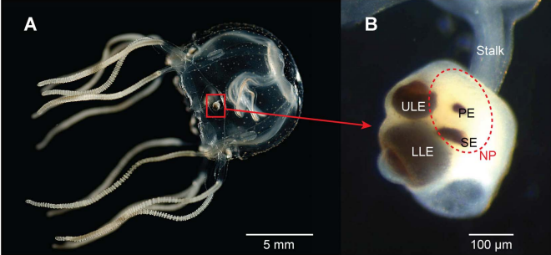

Figure 1: Tripedalia cystophora (A) and it’s rhopalium with the upper lens eye ULE, lower lens eye LLE, pit eye PE and slit eye SL source Bielecki et al 2014

Five opsins have been identified from de novo transcriptome data from the cubomedusan species *Tripedalia cystophora*, these opsins have been shown to be in the same clade as opsins identified in other *Cnidaria* (Nielsen et al 2019). The five opins found are TCY: 38276, 37162, 4539, 9518 and 32089, in the following paper 3 of these opsins will be utilized

The eyes of the *Cubozoan* have been shown to support behaviours like obstacle avoidance and mating (Garm et al 2007a), the nervous system of the animal must be able to handle the input from the sensory components found in the rhopalia. Therefore the central nervous system of *Tripedalia* is rather well defined (Garm et al 2007b), the eyes of the species have been studied far and wide as it is extremely complex and well defined. The species have even been shown to be able to use terrestrial cues in their navigation, the species utilize the relative position of it’s upper lens eyes to stay in the shade of mangroves (Garm et al 2011).

This project will utilize immunostaining to investigate the eye structure of these animals, the opsins that are screened for have been identified from the transcriptome of adult *Tripedalia*.

In the following paper I will work with some of the species mentioned above. The *Tripedalia*, *Sarsia, Cassiopeae* and *Aurelia* are the 4 chosen species. The work has been focused on the medusae, as Nakanishi 2009 implies that the sensory development of vision associated parts of the rhopalia occurs late in the developmental cycle of the animals. Both polyp, juvenile and adult *Tripedalia* were used, this was done to assure that the presence of opsins could be proven when it occurred.

# Method

## Animals

Subjects are stored at the marine biological department of Copenhagen university, they are grown in separate tanks at appropriate conditions. The subjects used are from the species *Cassiopea sp, Sarsia sp, Aurelia aurita* and *Tripedalia cystophora*, they were kept in 250 L tanks in temperature controlled rooms. They were fed *Artemia salina* nauplii, during the experiment the feeding procedure changed. Due to a lack of growth the *Artemia* were enriched with Selco, otherwise the environment in which subjects were grown stayed unchanged.

## Opsins

The opsins investigated in this paper have been identified by Anders Garm et al  
Antibodies and peptides have been ordered from Genosphere, they have the following amino sequences and names

*T.cys* 9518: RPEQTSVSAPTTQAVTAANA referred to as opsin 1 in the results section  
*T.cys* 37162: ASGVQPEKENTNTVETTREP referred to as opsin 2 in the results section  
*T.cys* 4538: GLDESEIMPTEGQEPDGQPEIT referred to as opsin 3 in the results section

## Immunostaining procedure

The investigation of the larger subjects start by dissecting the rhopalia and surrounding tissue from live subjects, this is done under a stereomicroscope. The organic matter is then fixed for an hour with 4% paraformaldehyde+PBS+5% Sucrose. In some cases entire specimens are used, this is especially in regards to *Sarsia* and juvenile *T. cystophora*.

The rhopalias can be stored in a fridge in a PBS buffer+ PAF, this is only when subjects are not for immediate use.

The rhopalias are then cleaned by being washed with PBS buffer with triton and bovine serum albumin (PBS +0.1% TritonX+0.5% BSA), the washing procedure is as follows.

|  |  |
| --- | --- |
| Instant | 2 times |
| 5 minutes | 2 times |
| 15 minutes | 2 times |
| 1 hour | 2 times |

The washing procedure is as follows: Add PBS with triton and wait, when the time required is elapsed PBS is drained and another round of buffer is added.

After the first wash the primary antibody for the immunostaining is added, then after a 72 hour period the washing process repeats, this time with PBS + 4% triton and BSA. After the second washing process the secondary antibody can be added, the material must from then on be handled under red light. After 24 hours elapse the material can be washed with pure PBS solution and mounted on a glass slide.

The cleaned subjects are fixed between glass slides in glycol, nail polish is used to seal the fixed subjects. They are marked with antigen, test number and name of student, they are also kept in a folder placed into a refrigerator which is wrapped in tinfoil marked with the date of fixation.

## Polyp

Polyps were sourced from the same tanks as the adult and juvenile specimens, here via asexual reproduction a stock of polyps are present. The polyps were removed from the tank and held at the same temperature and salinity as the adult specimens, they were removed to starve them.

The polyps were then sedated as in an attempt to prevent them from retracting their tentacles, the sedative was 7% magnesium chloride which was slowly introduced to their water.

## Confocal microscopy procedure

The scans are made in a Leica confocal microscope, the software used for the analysis are also made by Leica.

First the lasers for the microscope are started, the ventilation must be started 20 minutes before activation of the laser. The laser used is AG 488, as this wavelength is the one fitting for the scan. The beginning and end point of the scan is set at the resolution of 512x512, the average utilized for the scans are set between 3-5 images to reduce the noise. The setting for the actual scan is 1024x1024 and the scan should be around 25-50 depending on the depth of the sample. After setting the new resolution the gain and offset is adjusted as to minimize noise, the scan is run via the series function.

The transmission function is used to take a picture of the subject, the scan can then be layered onto this picture. The compiled image shows where staining has occurred relative in the subject.

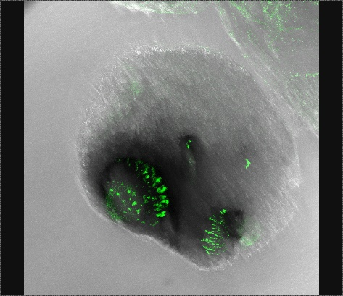  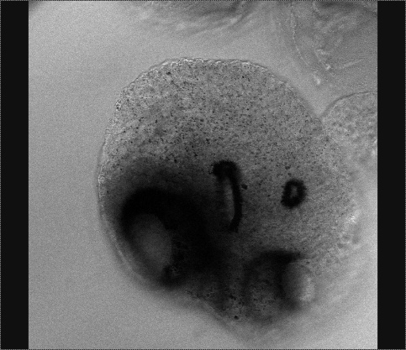

Figure 2: Example of how the scans are compiled to form a single image

As shown above the single picture showing the relative position of the staining is compiled from the 2 individual types of scans, this being done in the software as to minimize possible bias when layering the pictures.

## Pre-absorption experiment

The Pre-absorption experiment is done, to prove that the antigens exclusively target the designated opsins. A solution of the target peptide is mixed with the primary antibodies, this mix is incubated for 1 night. The antibodies and peptide should bind, therefore when the mix is added to wells with *T. cystophora* there shouldn’t be any staining.

# Results

The opsins are referred to by the number given in the methods section of this paper, this is done for brevity and clarity.

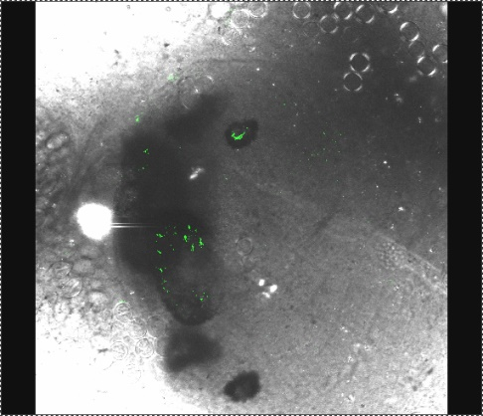  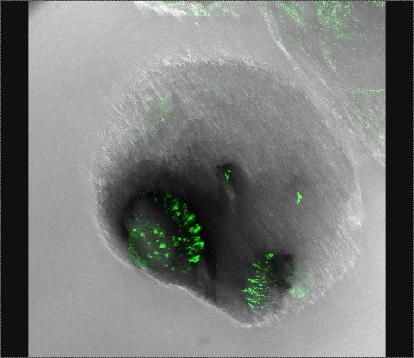

The light used in some of the scans was refracted through the lenses of the upper lens eye and the lower lens eye, this results in the scans of the rhopalia indicating a staining of the lenses. This can be seen in the picture of the scan at the 488 nm wavelength,

Opsin 1 is shown to be staining all 4 eyes of the rhopalia, the staining is not equal as the slit eye seems to be stained to a lesser degree than the lens eyes and pit eye. Normally the presence of 2 opsins in a single eye indicate colour vision, this however does not seem to be the case with *T. cystophora* as the vision of the upper lens eye have been studied intensely. Garm et al 2011 indicate that the vision of the upper lens eyes has a good spatial resolution, however it does not indicate that they utilize colour vision

Opsin 2 is only associated with the slit eyes in *Tripedalia*, this indicates that opsin 2 is the opsin responsible for vision in these eyes. Thus showing that the slit eyes are not only morphologically eyes, but that they in fact also serve as functioning eyes.

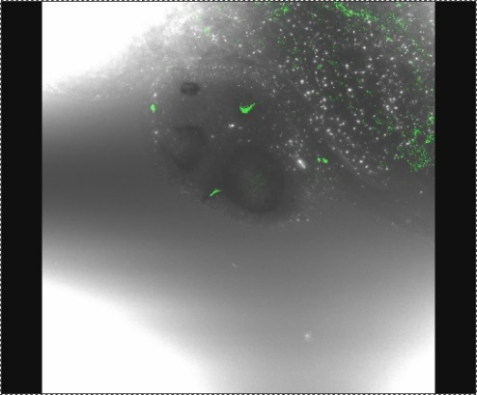 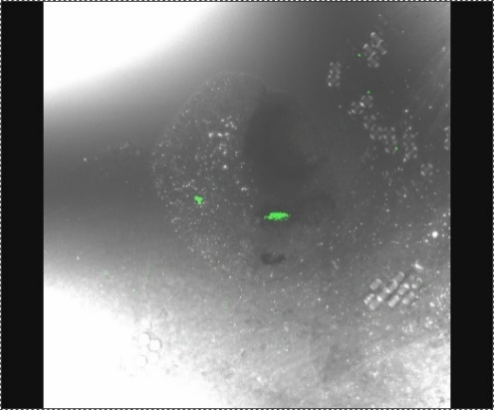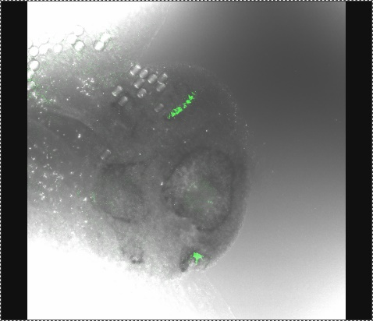

The other species didn’t show any indication that the opsins were present, there was some fluorescence in the menurbrium and tentacles of *Sarsia*



The staining seems more general than specific, the staining also occurs with all antibodies. Therefore it could be the case that it is autofluorescence instead of staining, this

# Discussion

The fact that opsin 1 was expressed in all 4 eye types might indicate that it is a shared trait amongst other species, even though it wasn’t expressed in any of the other species in this project. The animals we have looked at have all been from different groups of *Cnidaria*, it could be the case that the trait is only shared amongst other cubozoans. Cubozoans in general share a lot of traits in their visual ecology, they share the same setup with 24 eyes and the 4 types (Nillson et al 2005). The crystalline of their lenses have been found to form a novel family (Piatigorsky et al 1993), this part of the eye structure was theorized to have been replicated around 100 million years earlier. The crystalline was also a shared trait among cubomedusan eyes, this could indicate that the eyes of the entire family share a large portion of their traits. The high degree of similarity might indicate that opsin 1 might be found in other cubomedusan species, research into cubozoan vision is often done with *T. cystophora* as the species is small and easy to hold in stock.

A comparison amongst species of cubozoans could prove if the opsins, especially in regards to opsin 1 it might be a trait shared amongst the class. The function of having 2 opsins present in the eyes can be inferred, as it doesn’t appear that *Tripedalia* has colour vision, the fact that there are a secondary opsin might indicate its function to be as a dimer to the utilized opsin.

The relatively poor resolution image that cubomedusae produce has an analogue in the insect kingdom, here some animals use a degraded resolution in their course stabilization and navigation (Rüdiger Wehner 2005). In both cases the image produced by the lenses are out of focus, this means that the picture looses detail.

There has recently been evidence that cnidocyte discharge are regulated via phototransduction, Plachetzki et al 2012 found that *Hydra magnipapillata* expressed opsins, CNG ion channels and arrestin. This indicates that discharge is influenced by level of irradiance, via behavioral experimentation they also saw that discharge was less frequent under high irradiance conditions. They discuss whether the same could be a possibility in other cnidarians, as the fine tuning of cnidocyte discharge seems to benefit them both in prey capture and protection against predators. Cnicodytes have also been found to play a role in cubozoan copulation, cnicodytes in spermatohpores anchor to the females gonads (Helmark and Garm 2019). The observations was made on the species *Copula sivickisi* which is in the family *Tripedaliidae*,